**INFRARED PULSE SENSOR**

**FINAL REPORT**

**PROJECT – $EE251$**

**PRINCIPLES OF ELECTRICAL MEASUREMENTS**

$E /17/183$ $E/17/043$ $E/17/045$

# **SENSOR – INFRARED PULSE SENSOR**

# **INTRODUCTION**

In EE251 – Principles of Electrical Measurements, Second Year Project, we are asked to design a sensor that can convert some physical quantity into a voltage or a current. Therefore, we decided to design an Infrared pulse sensor. Taking pulse is as simple as holding a finger to your neck or wrist. But if we want to record and plot the signal of it, we have to convert that physical quantity into an electrical signal. By using this sensor, we are going to measure our pulse rate and plot the pulse signal wave of the change of pulse rate. The sensor is designed to use our fingertip to measure pulse rate (input – Physical quantity). A pulse wave is the change in the volume of a blood vessel that occurs when the heart pumps blood, and a detector that monitors this volume change is called a pulse sensor. The pulse rate is bpm (beats per minutes) (A normal resting pulse rate for adults from 60-100 bpm)

# **PROCEDURE**

In this project we mainly hope to convert a physical signal into an electrical signal. The infrared pulse sensor detects the change of blood flow of fingertip and that physical signal converts into an electrical signal and passes to Arduino Uno board through the circuit. The sensor itself consists of an infrared emitter and detector mounted side by side and pressed closely against the skin. When heart pumps, blood Pressure rises sharply and so does the amount of light from emitter. That amount of light gets reflected back to the detector. The detector passes more current when it receives more light, which in turn causes a voltage drop to enter the amplifier circuitry which passes the signal to Arduino board. Finally, we can see the changing pulse rate through the Arduino software interface from the computer and pulse wave signal from Processing 2.0.3 software interface from the monitor.

# **CALIBRATION**

After making the sensor we are going to calibrate it by using portable arm blood pressure monitor (with pulse detector). we will measure the same person pulse using our sensor and this machine. By doing this to few people, we can use a graphical method to calibrate our sensor.

# **OBJECTIVES OF THE PROJECT**

* In this project we mainly hope to convert a physical signal into an electrical signal.
* In addition, we hope to understand the basic theory of any sensor and how they work, further we hope to get a good knowledge about electronic components
* This device can be used as a “Medical Device” that can be measured the pulse rate of someone and get idea about him and his blood circulating system.
* The device can be developed as a “Truth Detector”. We can see what happens to the final pulse signal when you laugh or tell a lie. (We can analyze the pulse signal on our purpose.)

# **CIRCUIT DIAGRAM**

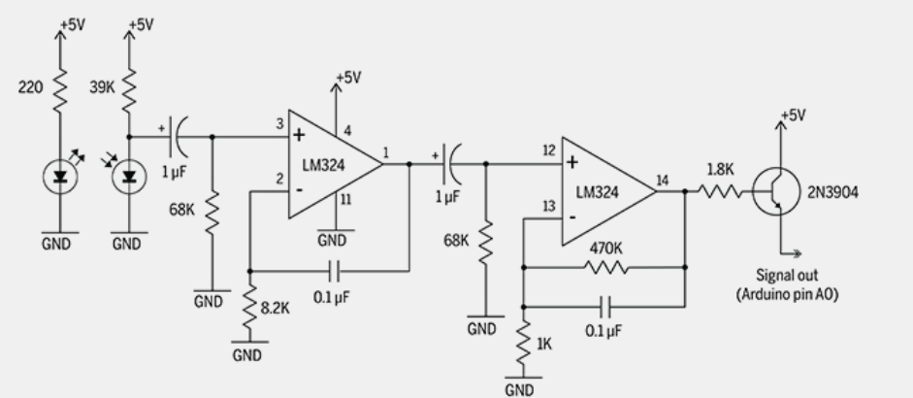

FIGURE 01

# **ELECTRONIC COMPONENT REQUIREMENT**

|  |  |  |
| --- | --- | --- |
| $$LM324 IC$$ | | 1 |
| Resistors | $$68k$$ | 2 |
| $$220$$ | 1 |
| $$8.2k$$ | 1 |
| $$1.8k$$ | 1 |
| $$470k$$ | 1 |
| $$39k$$ | 1 |
| Capacitors | $$0.1 μF Ceramic$$ | 2 |
| $$1 μF Tantalum$$ | 2 |
| $2N3904$ Transistor | | |
| $IR LED$ Emitter and Detector | | |
| A Piece of $Dot Board$ or A $Bread Board$ | | |
| Intercom Wires | | |
| An Arduino UNO Board | | |